**DEVELOPMENT SETUP**

1. Select Your Operating System (OS):

   Choose an operating system that best suits your preferences and project requirements. Download and Install Windows 11

- My PC came with windows 11 pre-installed. However I had to remove certain Execution

Policies on my PC in order to run some software.

2. **Installing an Integrated Development Environment.**

**Step 1: Visit the Official website of the Visual Studio Code using any web browser like Google Chrome or Microsoft Edge (in my case I used Google Chrome: https://code.visualstudio.com/download)**

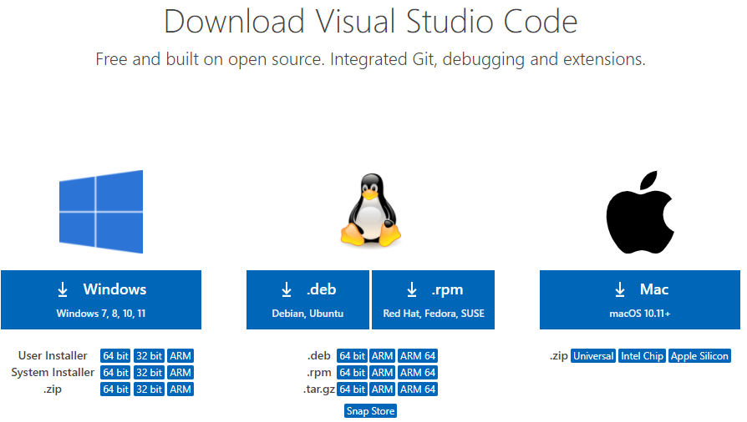

**Step 2: Press the “Download for Windows” button on the website to start the download of the Visual Studio Code Application.**



**Step 3: When the download finishes, then the Visual Studio Code Icon appears in the Downloads folder.**

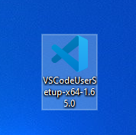

**Step 4:** Click on the Installer icon to start the installation process of the Visual Studio Code.

**Step 5**: After the Installer opens, it will ask you to accept the terms and conditions of the Visual Studio Code. Click on **I accept the agreement**and then clickthe **Next**button.

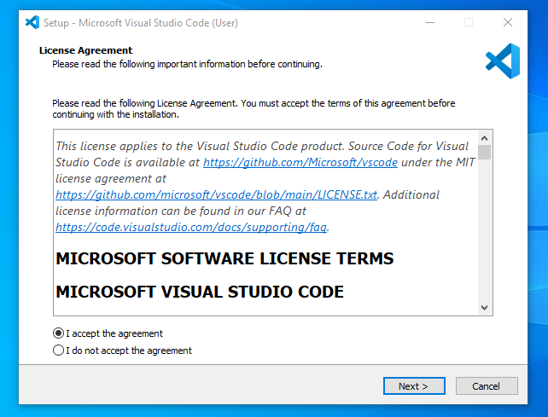

**Step 6:** Choose the location data for running the Visual Studio Code. It will then ask you to browse the location. Then click on the **Next** button.

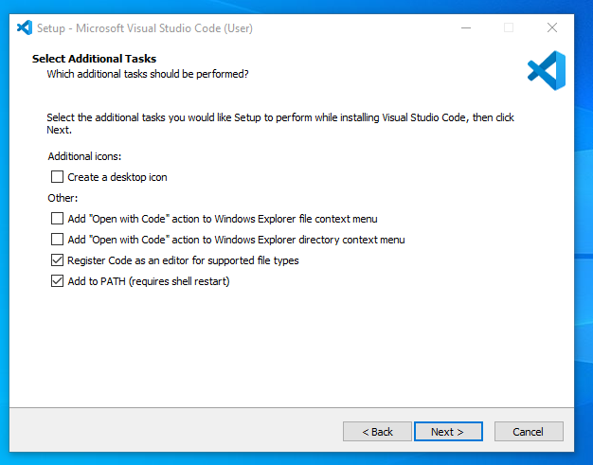

**Step 7:** Then it will ask to begin the installation setup. Click on the Install button.

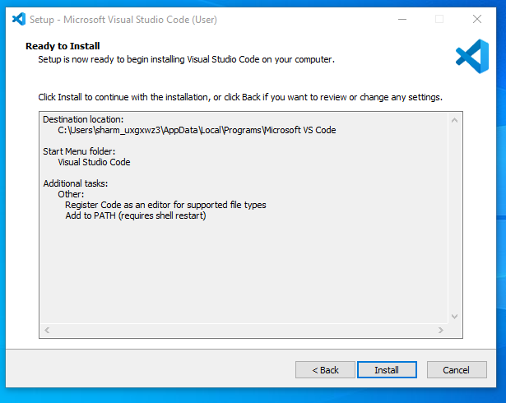

**Step 8:** After clicking on Install, it will take about 1 minute to install the Visual Studio Code on your device.

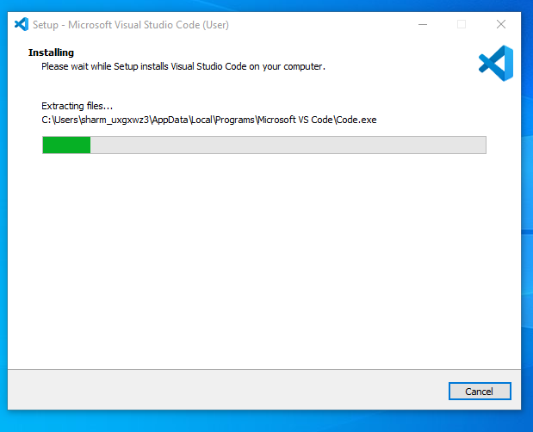

**Step 9:** After the Installation setup for Visual Studio Code is finished, it will show a window like this below. Tick the “**Launch Visual Studio Code**” checkbox and then click **Next**.

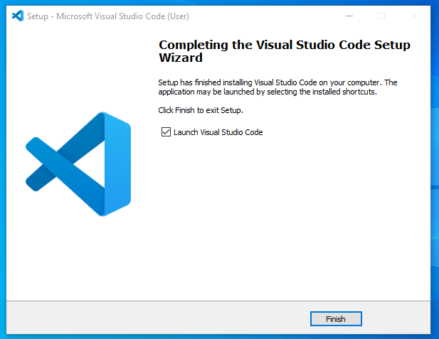

**Step 10:** After the previous step, the **Visual Studio Code window** opens successfully. Now you can create a new file in the Visual Studio Code window and choose a language of yours to begin your programming journey!

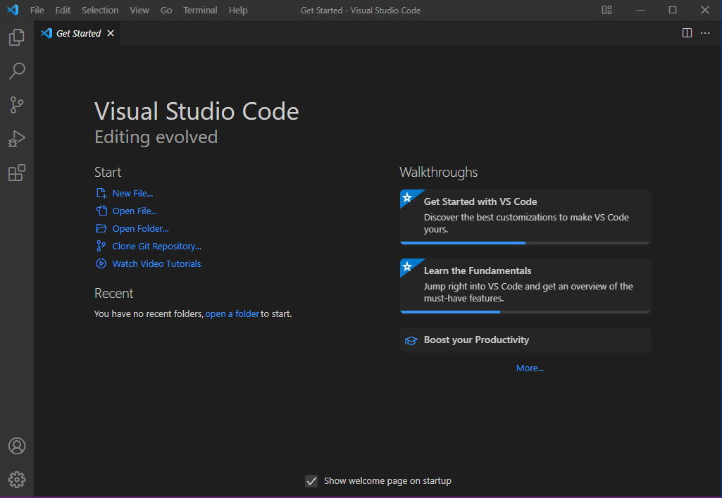

- So this is how we successfully installed**Visual Studio Code** on our Windows system. The steps mentioned in the above guideline can be used in any kind of Windows Browsers for **Downloading & Installation VS Code on Windows 10**. So, try these steps to get the **VS Code IDE** on your device as well.